Web Applications
Assignment 1
assignment1.php Value 20%
Write a program, called assignment1.php, which a user must complete in order to enter a horse for a Horse Sale.
- When this form has been completed correctly, the data the user entered is displayed on another form.
- The user can email this data to someone or return to the original (blank) form.
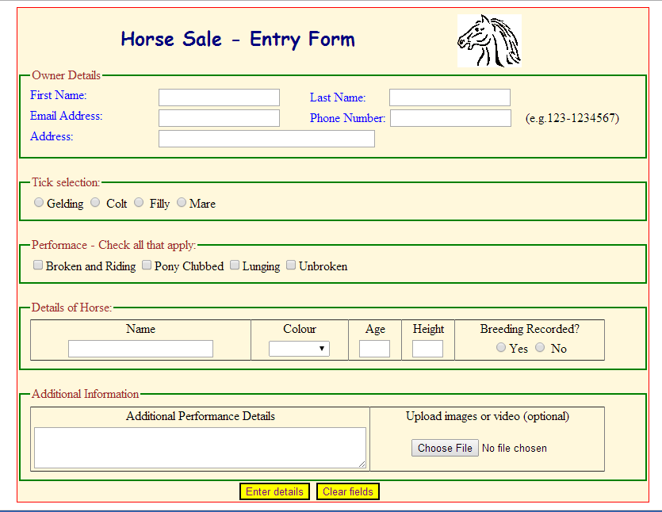

Figure 1
All data entered by the user must be validated, as follows:
- Check the first name and last name contains letters only, using a regular expression.
- Check the address contains letter, numbers, apostrophe etc., using a regular expression.
- Check the email is in a valid format e.g. paul@itb.ie, using a regular expression.
- Check the phone number is in the format 999-1234567, using a regular expression.
- For radio buttons, check that one radio button has been selected.
- For checkboxes, check at least one checkbox has been selected.
- For dropdown lists, check at least one item has been selected.
- For age & height, check that the entries are numeric
- For the textarea, check that the user had entered a comment
- The only form entry that is optional is the file upload – but the user must be able to do this.

(Note: Dropdown Menu – Values are: Bay, Chestnut, Piebald and White. The default value is blank, so the user must make a selection. )

If the user has left anything blank or any invalid data has been entered, display an error message (in red) and display the entries already completed by the user. i.e. as sticky input.
Error Messages to be displayed if the form is not completed correctly (Figure 2) :
- First name is invalid (letters, hyphens, ', only)
- Last name is invalid (letters, hyphens, ', only)
- Email is invalid (Format as xxx@yyy.ie)
- Phone number is invalid (Format as 999-9999999)
- Address is invalid (………)
- Please select the sex of the horse
- Tick a box in the Performance section
- Name of the horse in invalid (letters, hyphens, ', only)
- Select colour of horse
- Enter Age correctly
- Enter Height correctly
- State whether the Breeding is recorded
- Enter additional Performance Details
These messages should be displayed as an ordered list (i.e. numbered). There are 13 messages in all.
You must use regular expressions to validate – name, address, phone number and email fields. You will receive assistance with this part of the CA.
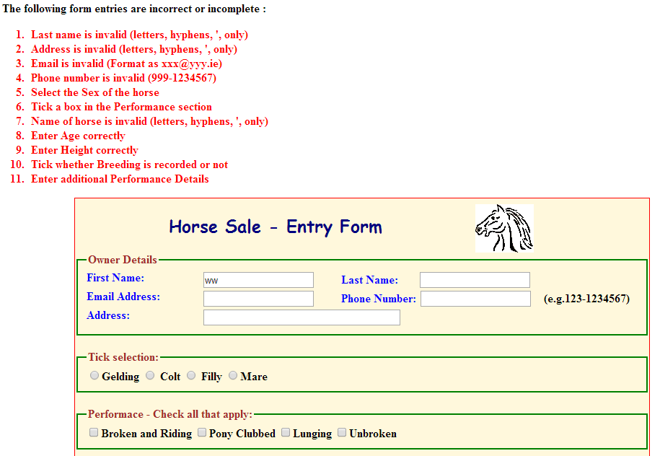

Figure 2

When the user has completed the form correctly, display the form entries in a form with a textarea field, and a button “Send Thru Email”. When this button is pressed, the entries displayed are emailed to yourself (or anyone else). The form must send its data to an email address < form action = “email address” …> [More notes of email will be provided]
Note: You can’t format the content of the textarea.
- Use \n to put content on a new line. Use \t to tab content for lining up.
- Provide a hyperlink on this form that allows the user to return to the Gym Questionnaire page.
- You must state whether the user uploaded a file or not. You can retrieve the name of the file in the normal way.
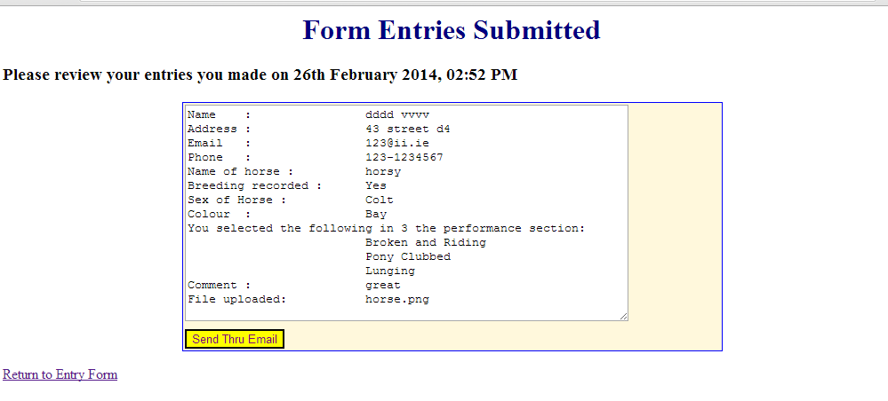
Figure 3

Note: This assignment should consist of one program – an “all-in-one” form which contains functions. Alternatively, it may consist of one main php program which calls include files.
The assignment is based, largely, on the content of Lecture 5 – on creating sticky forms.

Form: It does not have to be laid out exactly, as shown in the screengrab, but you should limit the scrolling on the form page. Use fieldsets to organise the form elements. Align the fields in your form, using CSS. ( In the Figure 1 above, the section Details of Horse was laid out using a table).
CSS – You must use an external style sheet

Submission Requirements:
Submit your program via Moodle, as a zip file.
Name your file, as follows e.g. assignment1.php

Deadline for Submission:
- Assignment1 --- THURSDAY 20th MARCH 2014(CHECK time on MOODLE)
- Penalty for late submissions – 10% per day
- No submissions will be accepted after the LATE SUBMISSION DEADLINE of SUNDAY 23rd MARCH 2014 (CHECK time on MOODLE)

Correction of Assignments:
- You will be required to demonstrate and answer questions on your assignment in a lab session, where the quality of your code will be examined.

HANDUP DOCUMENTATION (when assignment being viewed in the lab)
Provide screengrabs (black and white will do) of the following:
- Form showing error messages – similar to Figure 2 in this handout
- Form showing entries submitted – similar to Figure 3 in this handout
- You must provide a cover sheet with your name, student number and group on it.
- The documentation must be stapled
- Don’t lose marks in this part of the CA.

NOTE
Do not attempt to write all the code together. It is a long program.
Write a little, test it & get it right, before going onto the next aspect of the code.
Put in “trace” i.e. echo statements to determine where you are in the code, or to find out what values are being read.
You can take code from one of the Sample Programs on Sticky Forms as a starting point.
Alter and extend the code in one of these programs, so that you start on the right track.

